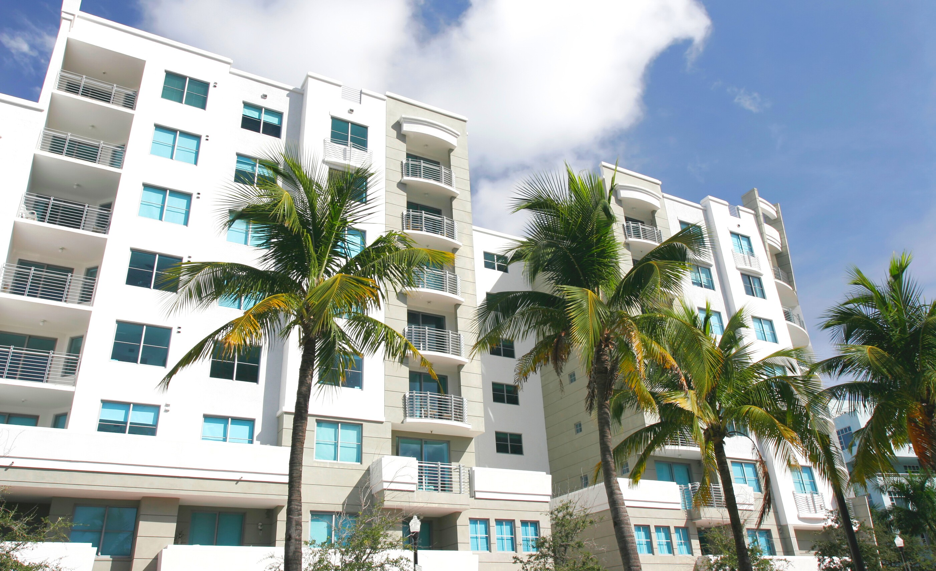
Your logo here

Own an Investment Property?
Get cash from the home's equity!

Enjoy the flexibility of a Home Equity Loan:
Borrow up to 80% of the home's value
Finance up to 10 properties
Minimum credit score of 640
Loan amounts up to $500,000

Call me today!
Your Name
youremail@youremail.com www.yourwebsite.com NMLS #
123-456-7890

